Assignment #2 - CSS Styling (Report)

Name: Ayan

Group:IT-2410

# Objective

By the end of this assignment I:  
- Learned to apply styles using inline, internal and external CSS.  
- Used selectors, classes, and IDs.  
- Practiced box model, positioning, and float/clear.  
- Created a styled multi-section webpage.

# Tasks and Screenshots

Task 0: Added styling to the existing HTML file. 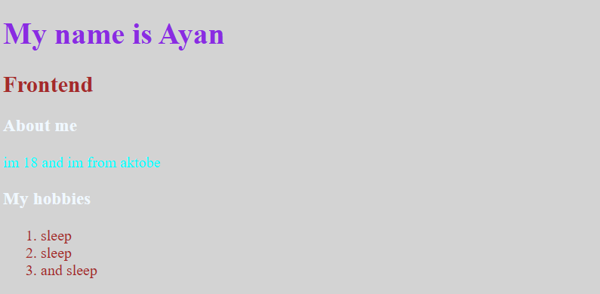Task 1: Inline CSS — changed color of one paragraph using inline style. 

Task 2: Internal CSS — added styles inside <head> with <style>. 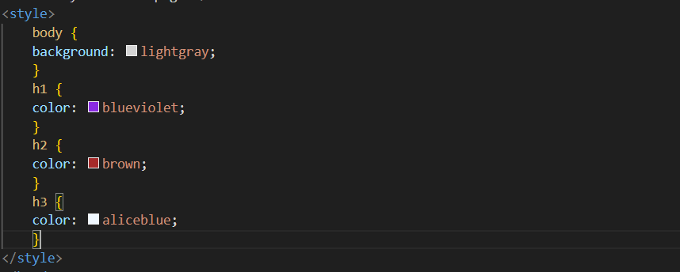

Task 3: External CSS — created style.css and linked it. 

Task 4: Used selectors: element, class and ID. 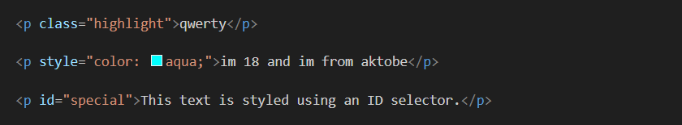

Task 5: Created .highlight class and #main-heading ID. 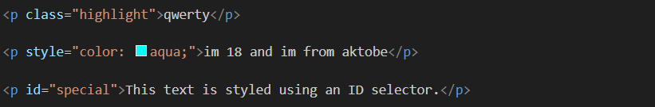Task 6: Added a favicon (favicon.png). 

Task 7: Used <div> sections for header, main and footer and styled them. 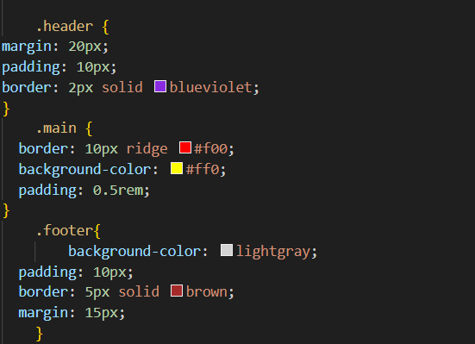

Task 8: Box model demonstration with borders, padding and margins. 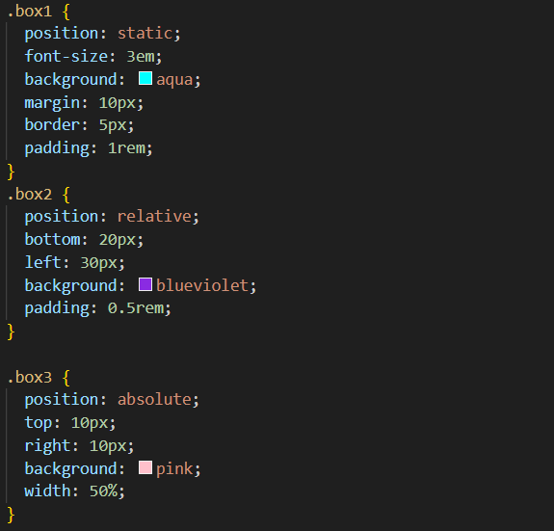

Task 9: Positioning demo with static, relative and absolute elements. 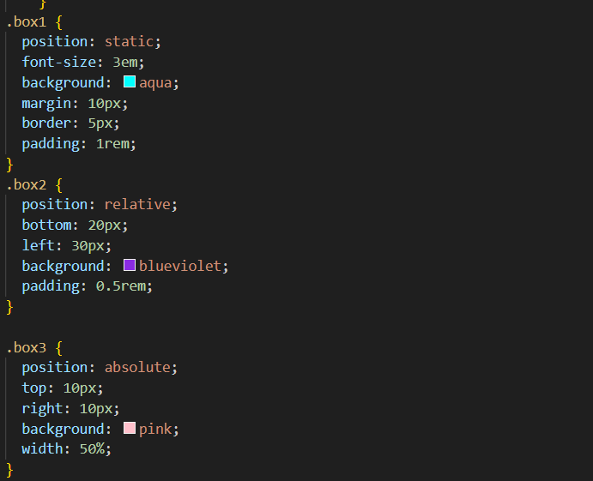

Task 10: Sizing using px, em, rem and % units. 

Task 11: Float and clear demonstration with two floated boxes. 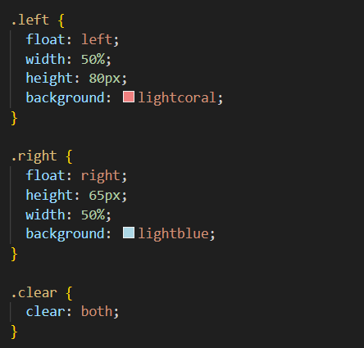

# Summary

I created a styled webpage demonstrating inline/internal/external CSS, selectors, and layout techniques. During the work I learned how small CSS changes affect layout and spacing.